1. Signal
Signal is a specific message sending to the whole threads group or a specific thread. SIGKILL and SIGSTOP can’t be ignored, captured and blocked.
Regular signal: 0~31. When a regular signal is sending several times, but it will be handle once only and not be queued.
Real-time signal: 32~63. When a real-time signal is sending several times, all of them will be queued and handled.

2. Signal in task
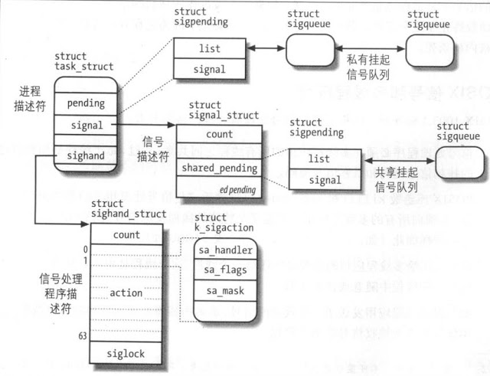

struct sighand_struct {
atomic_t count; /*How many task shared it*/
struct k_sigaction action[_NSIG];
};

struct sigpending {
struct list_head list;
sigset_t signal;
};

struct task_struct
{
/*signal descriptor: contains the shared sigpending of the whole thread group*/
struct signal_struct *signal;

/*signal handle descriptor: contains the handler of each signal*/
struct sighand_struct *sighand;

/*the private sigpending of the thread/Task*/
struct sigpending pending;

/which kinds of signal are block for this task*/
sigset_t blocked;
};

3. Signal handle
1). Install a new handler for a signal in current task
a. signal
one-shot handle, if the signal is be handle once, the handle will be rollback to the default value. This signal will not be blocked when the handler is calling. And also don’t mask other signal.

SYSCALL_DEFINE2(signal, int, sig, __sighandler_t, handler)
{
struct k_sigaction new_sa, old_sa;
int ret;

new_sa.sa.sa_handler = handler;
new_sa.sa.sa_flags = SA_ONESHOT | SA_NOMASK;
sigemptyset(&new_sa.sa.sa_mask);

ret = do_sigaction(sig, &new_sa, &old_sa);
}
b. sigaction: manual set the sigaction data.

sys_sigaction(int sig, const struct old_sigaction __user *act, struct old_sigaction __user *oact)
{
ret = do_sigaction(sig, act ? &new_ka : NULL, oact ? &old_ka : NULL);
}

int do_sigaction(int sig, struct k_sigaction *act, struct k_sigaction *oact)
{
struct task_struct *t = current;
k = &t->sighand->action[sig-1];
if (oact)
*oact = *k;
if (act) {
/*can’t block the SIGKILL and SIGSTOP*/
sigdelsetmask(&act->sa.sa_mask,
sigmask(SIGKILL) | sigmask(SIGSTOP));
*k = *act;
/*if the signal is pending and the new handler is ignored, it should remove the shared pending and private pending of the threads group*/
}
}

2). Block a signal on current task
sigpromask
SYSCALL_DEFINE3(sigprocmask, int, how, old_sigset_t __user *, nset,
old_sigset_t __user *, oset)
{

old_set = current->blocked.sig[0];

if (nset) {
/*can’t block SIGKILL and SIGSTOP*/
new_set &= ~(sigmask(SIGKILL) | sigmask(SIGSTOP));

new_blocked = current->blocked;

switch (how) {
case SIG_BLOCK:
sigaddsetmask(&new_blocked, new_set);
break;
case SIG_UNBLOCK:
sigdelsetmask(&new_blocked, new_set);
break;
case SIG_SETMASK:
new_blocked.sig[0] = new_set;
break;
default:
return -EINVAL;
}

__set_current_blocked(&new_blocked);
}
………
return 0;
}

3). Send a signal
i.) send a signal to a process (thread group)
SYSCALL_DEFINE2(kill, pid_t, pid, int, sig)
{
info.si_signo = sig;
info.si_errno = 0;
info.si_code = SI_USER;
info.si_pid = task_tgid_vnr(current);
return kill_something_info(sig, &info, pid);
}
kill_something_info(int sig, struct siginfo *info, pid_t pid)
{
/*send it to the group leader of the thread group*/
if (pid > 0) {
rcu_read_lock();
ret = kill_pid_info(sig, info, find_vpid(pid));
rcu_read_unlock();
return ret;
}
}

int kill_pid_info(int sig, struct siginfo *info, struct pid *pid)
{
struct task_struct *p;

p = pid_task(pid, PIDTYPE_PID);
if (p) {
group_send_sig_info (sig, info, p);
}
}
group_send_sig_info(int sig, struct siginfo *info, struct task_struct *p)
{
/*send to the group with true parameters*/
send_signal(sig, info, p, true);
}

ii). send a signal to a specific thread in a thread group
SYSCALL_DEFINE3(tgkill, pid_t, tgid, pid_t, pid, int, sig)
{
info.si_signo = sig;
info.si_errno = 0;
info.si_code = SI_TKILL;
info.si_pid = task_tgid_vnr(current);

return do_send_specific(tgid, pid, sig, &info);
}

do_send_specific(pid_t tgid, pid_t pid, int sig, struct siginfo *info)
{
struct task_struct *p = find_task_by_vpid(pid);
/*the group leader of p must be tgid */
if (p && (tgid <= 0 || task_tgid_vnr(p) == tgid)) {
send_signal(sig, info, p, false);
}
}

int send_signal(int sig, struct siginfo *info, struct task_struct *t, int group)
{
/*if group put it on shared_pending, otherwise put it on private pending*/
struct sigpending *pending = group ? &t->signal->shared_pending : &t->pending;

/*allocate the sigqueue and list it to pending->list*/
struct sigqueue *q = __sigqueue_alloc(sig,t,...);
list_add_tail(&q->list, &pending->list);

sigaddset(&pending->signal, sig);
complete_signal(sig, t, group);
}

static void complete_signal(int sig, struct task_struct *p, int group)
{
/*if main threads task in group or specific task can receive it then set it as the target*/
if (wants_signal(sig, p))
t = p;
else if (!group || thread_group_empty(p))
/*
* There is just one thread and it does not need to be woken.
* It will dequeue unblocked signals before it runs again.
*/
return;
else {
/*
* Otherwise for group threads try to find a suitable thread.
*/
t = signal->curr_target;
while (!wants_signal(sig, t)) {
t = next_thread(t);
......
}

signal->curr_target = t;
}

/*
* The signal is already in the shared-pending queue.
* Tell the chosen thread to wake up and dequeue it.
*/
/*set the TIF_SIGPENDING flag and wake up the target*/
signal_wake_up(t, sig == SIGKILL);
}
- . Handle a signal
When a task resume to userspace, It will call do_notify_resume to check whether a signal is coming for itself.
do_notify_resume()
{
/* deal with pending signal delivery */
if (thread_info_flags & _TIF_SIGPENDING)
do_signal(regs);
}

static void do_signal(struct pt_regs *regs)
{
struct ksignal ksig;

if (get_signal(&ksig)) {
/* Whee! Actually deliver the signal. */
handle_signal(&ksig, regs);
return;
}
}

int get_signal()
{
for(;;)
{
/*dequeue the signr from share_pending and pending without blocked*/
signr = dequeue_signal(current, &current->blocked, info);
ka = &sighand->action[signr-1];

if (ka->sa.sa_handler == SIG_IGN) /* Do nothing. */
continue;
if (ka->sa.sa_handler != SIG_DFL) {
/* Run the handler. */
*return_ka = *ka;

if (ka->sa.sa_flags & SA_ONESHOT)
ka->sa.sa_handler = SIG_DFL;
break; /* will return non-zero "signr" value */
}

/*did a default action of the signal*/
.......
}

}

Void handle_signal(struct ksignal *ksig, struct pt_regs *regs)
{
/* Are we from a system call? */
if (syscall_get_nr(current, regs) >= 0)
{
xxxx
}
/*setup frame for user space signal handler
failed = (setup_rt_frame(ksig, regs) < 0);
signal_setup_done(failed, ksig, test_thread_flag(TIF_SINGLESTEP));
}

signal_setup_done--->signal_delivered
void signal_delivered(int sig, siginfo_t *info, struct k_sigaction *ka,
struct pt_regs *regs, int stepping)
{
sigset_t blocked;

/* A signal was successfully delivered, and the
saved sigmask was stored on the signal frame,
and will be restored by sigreturn. So we can
simply clear the restore sigmask flag. */
clear_restore_sigmask();

/*temporary modifies the blocked, It will be restored after the handler is done */
sigorsets(&blocked, &current->blocked, &ka->sa.sa_mask);
if (!(ka->sa.sa_flags & SA_NODEFER))
sigaddset(&blocked, sig);
set_current_blocked(&blocked);
}

- . Others
- Userspace: sigpending
/*to check if there are some signal pending that is blocked*/
SYSCALL_DEFINE2(sigpending, sigset_t __user *, uset, size_t, sigsetsize)
{
sigset_t set;
int err = do_sigpending(&set, sigsetsize);
if (!err && copy_to_user(uset, &set, sigsetsize))
err = -EFAULT;
return err;
}
b. Kernel: signal_pending
/*to check if there a signal pending on this Task*/
static inline int signal_pending(struct task_struct *p)
{
return unlikely(test_tsk_thread_flag(p,TIF_SIGPENDING));
}

c. Kernel thread: it prohibits accept any signal in default. Programmer must enable it through allow_signal(signr)

static int my_thread(void *nothing)
{
allow_signal(SIGINT);
do{
printk(KERN_INFO "thread is running...\n");
timeout = HZ;
while(timeout > 0)
timeout = schedule_timeout(timeout);
if (signal_pending(current)){
printk(KERN_INFO "Got signal\n");
thread_k = NULL;
break;
}
}while(!kthread_should_stop());
}

